Practical No. 15
Aim : 1) Design an applet/application to demonstrate the use of Radio buttons and Checkbox

Name : Danish Altaf Solkar | Class : CO - B
Enrolment no. : 24111590805 | Batch : 2

Code :-
import javax.swing.*;
import java.awt.event.ActionEvent;
import java.awt.event.ActionListener;
public class RadioButtonCheckboxApp {
public static void main(String[] args) {
JFrame frame = new JFrame("Radio Button and Checkbox Example");
frame.setDefaultCloseOperation(JFrame.EXIT_ON_CLOSE);
frame.setSize(300, 200);
JRadioButton radioButton1 = new JRadioButton("Option 1");
JRadioButton radioButton2 = new JRadioButton("Option 2");
ButtonGroup group = new ButtonGroup();
group.add(radioButton1);
group.add(radioButton2);
JCheckBox checkBox = new JCheckBox("Check me");
JButton button = new JButton("Submit");
button.addActionListener(new ActionListener() {
public void actionPerformed(ActionEvent e) {
String selectedOption = radioButton1.isSelected() ? "Option 1" : "Option 2";
String checkBoxStatus = checkBox.isSelected() ? "Checked" : "Unchecked";
JOptionPane.showMessageDialog(frame, "Selected: " + selectedOption +
"\nCheckbox: " + checkBoxStatus);
}
});
JPanel panel = new JPanel();
panel.add(radioButton1);
panel.add(radioButton2);
panel.add(checkBox);
panel.add(button);
frame.add(panel);
frame.setVisible(true);
}
}

OUTPUT :-
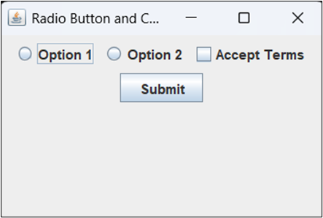

Aim : 2) Write a program which creates Menu of different colors and disable menu item for black color

Code :-
import javax.swing.*;
import java.awt.event.ActionEvent;
import java.awt.event.ActionListener;

public class ColorMenu {
public static void main(String[] args) {
JFrame frame = new JFrame("Color Menu");
JMenuBar menuBar = new JMenuBar();
JMenu colorMenu = new JMenu("Colors");

JMenuItem redItem = new JMenuItem("Red");
JMenuItem greenItem = new JMenuItem("Green");
JMenuItem blueItem = new JMenuItem("Blue");
JMenuItem blackItem = new JMenuItem("Black");

blackItem.setEnabled(false); // Disable Black Color Menu Item

colorMenu.add(redItem);
colorMenu.add(greenItem);
colorMenu.add(blueItem);
colorMenu.add(blackItem);

menuBar.add(colorMenu);
frame.setJMenuBar(menuBar);

frame.setSize(400, 300);
frame.setDefaultCloseOperation(JFrame.EXIT_ON_CLOSE);
frame.setVisible(true);
}
}

OUTPUT :-
